Date 07-05-2024

Hands on Lambda

Services Involved >>> S3, IAM & CloudWatch

https://docs.aws.amazon.com/lambda/latest/dg/with-s3-example.html

Step 1 >>> Create a IAM Role for Lambda to access the services >>> S3, CLoudwatch and Lambda

Roles >>> Create a Role >>> AWS service

>>> Use case >>>> Lambda >>> Next

AmazonS3FullAccess

CloudWatchFullAccess

AWSLambda_FullAccess

Next

Role name >>> IAMroleforLambda

Create a Role

Now go to S3 Bucket

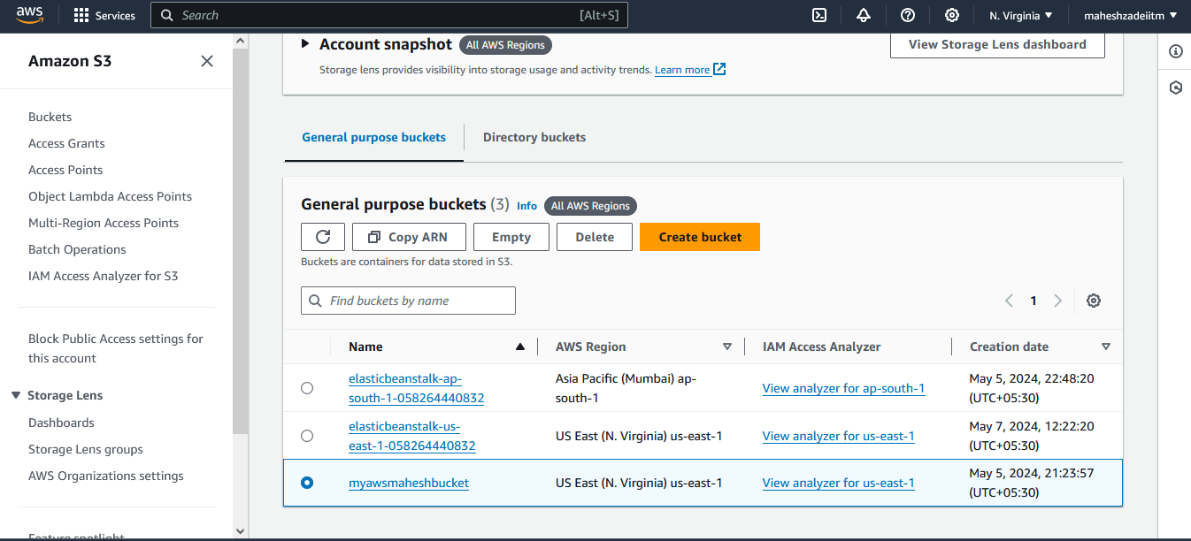

Give the read and Write permissions

Click on the I understand the effects of these changes on this object.

Save Changes

Step 2 >>> Create a S3 Bucket with default settings (or) choose the existing bucket –Created Above

But make sure S3 Bucket and Lambda both are in same Region

[myawsmaheshbucket](https://us-east-1.console.aws.amazon.com/s3/buckets/myawsmaheshbucket?region=us-east-1&bucketType=general)

Step 3 >>> Go to the Lambda >>> Create function >>>> Author from scratch

Function name >>> S3 with Lambda

Runtime >>> Nodejs-16.x

Architecture >>> x86_64

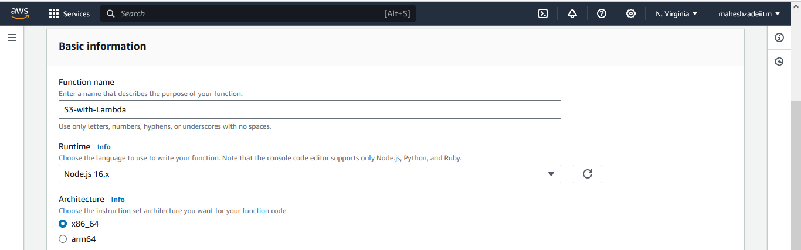

Change default execution role >>>> Use an existing role >>>> Select the role that you have created in Step#1

Create a Function .

Step 4 >>> Once you are inside the Lambda Function >>> Add trigger

>>>> Trigger configuration >>>> S3

Bucket >>>> Choose your Bucket

Event types >>> ALL

Check the box >>> I acknowledge

Add

Getting below error

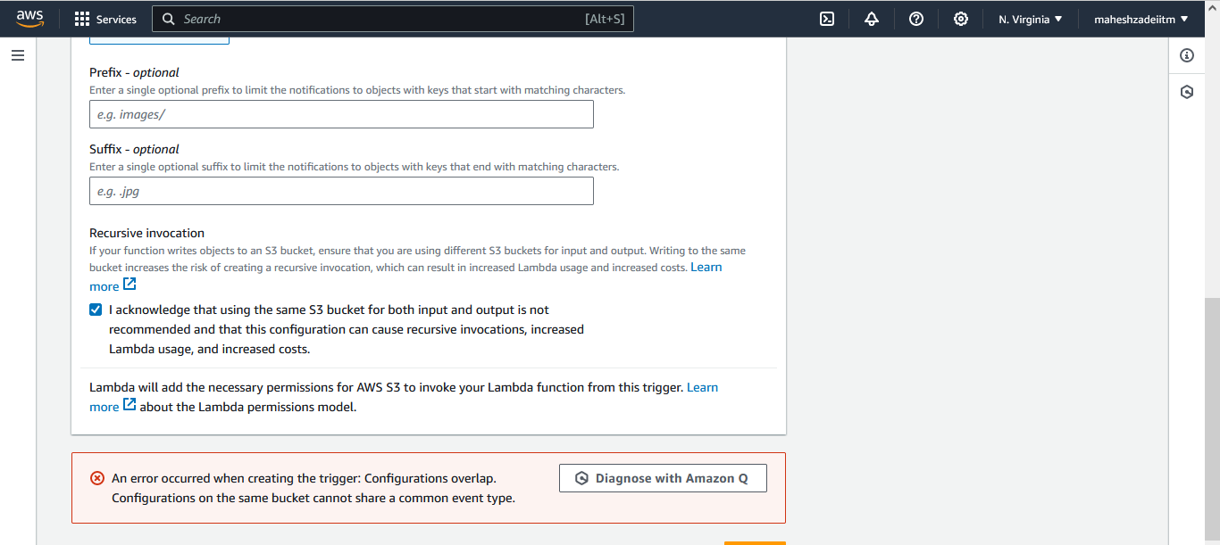

So create new event notification

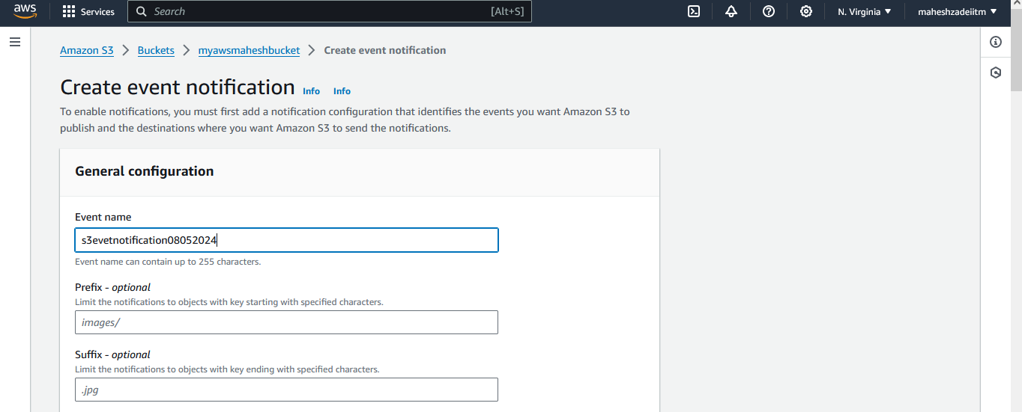

Troubleshooting as getting errors

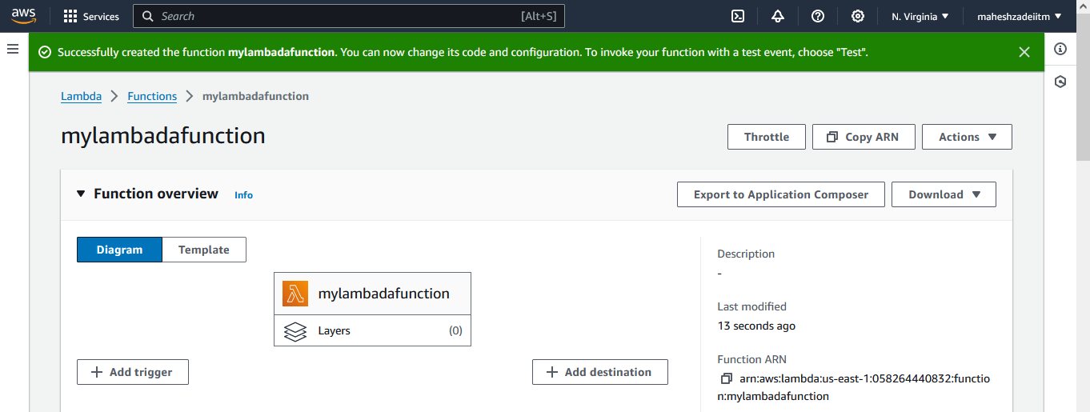

Step 5 >>> Now go to the Code at the bottom and delete that code, and replace with the below code

Now add the code below mentioned and save

exports.handler = function(event, context, callback) {

console.log("Incoming Event: ", event);

const bucket = event.Records[0].s3.bucket.name;

const filename = decodeURIComponent(event.Records[0].s3.object.key.replace(/\+/g, ' '));

const message = `File is uploaded in - ${bucket} -> ${filename}`;

console.log(message);

callback(null, message);

};

Once you have replaced >>> File >>> Save

Then >>> Click on "Test"

One time it will ask you to configure the test events

Event name >>>> s3events >>> Save

Again >>> Click on "Test"

Once test is completed you can see there is Status = "Succeeded"

Final Step >>>> Click on "Deploy"

At the top you can see a notification >>> Successfully updated the function **mylambadafunction**

Step 6 >>>> Now you can go to the "Monitor"

Click on View "CLoudwatch logs"

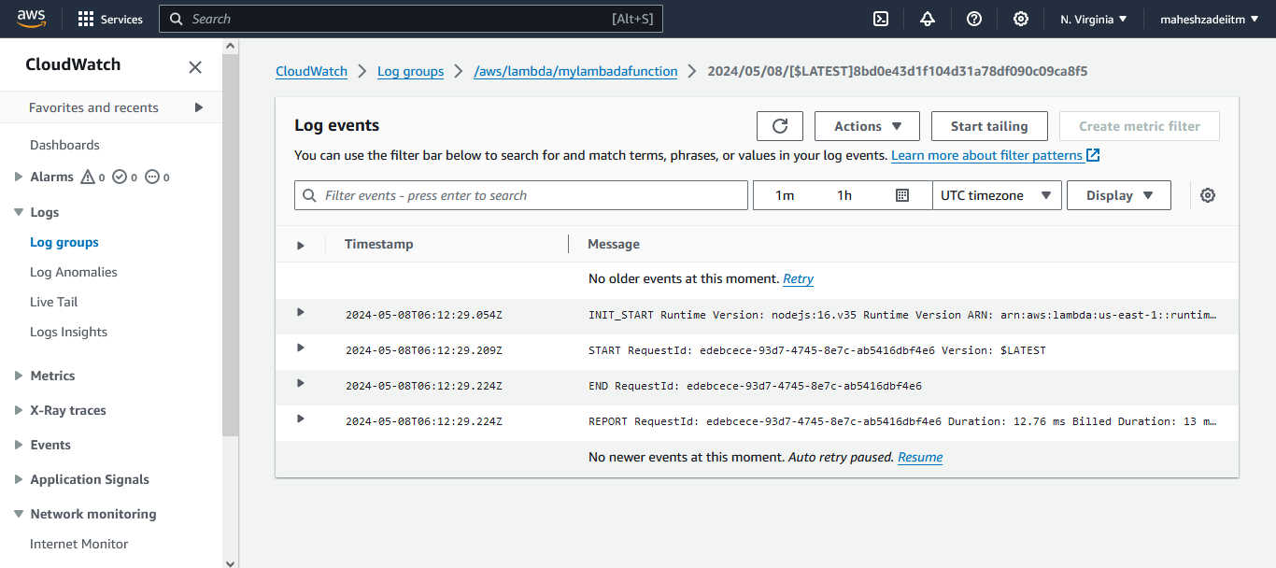

There you can see your log groups and Log streams

The configuration of the lambda for this scenario is completed here.

Testing ??????

Upload a file again and check the log group

Step 7 >>>> Testing

Copy the URL

https://myawsmaheshbucket.s3.amazonaws.com/saproutererror.png

Lambda Function done Successfully

Pls check and update

Thanks

ElasticBeanstalk Lab